CASE STUDY
import networkx as nx
import matplotlib.pyplot as plt

G = nx.Graph()
edges = {
('Churchgate', 'Mumbai Central'),
('Mumbai Central', 'Dadar'),
('Dadar', 'Bandra'),
('Dadar', 'Andheri'),
('Bandra', 'Andheri'),
('Andheri', 'Borivali'),
('Borivali', 'Virar')
}

G.add_edges_from(edges)
plt.figure(figsize=(8,5))
nx.draw(G, with_labels=True, node_color='lightblue',
node_size=3000, font_size=11)
plt.title("Mumbai Western Railway Network")
plt.show()
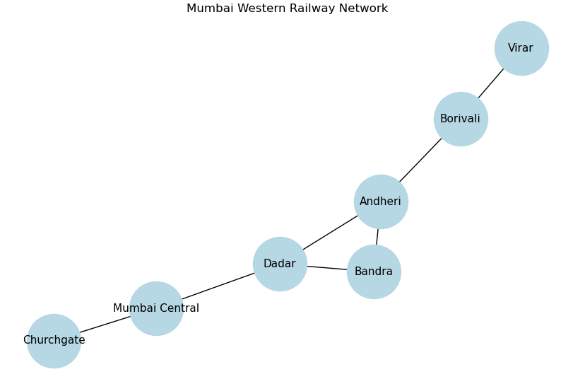

STEP 2: DEGREE CENTRALITY
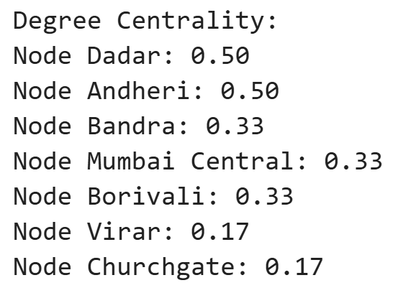
deg_centrality = nx.degree_centrality(G)
print("Degree Centrality:")
for node, cent in deg_centrality.items():
print(f"Node {node}: {cent:.2f}")

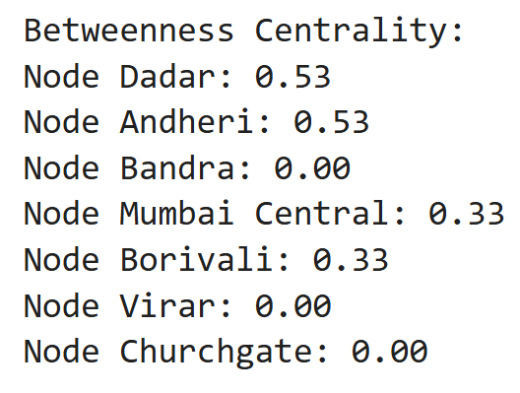
STEP 3: BETWEENNESS CENTRALITY
bet_centrality = nx.betweenness_centrality(G)
print("\nBetweenness Centrality:")
for node, cent in bet_centrality.items():
print(f"Node {node}: {cent:.2f}")

STEP 4: CLOSENESS CENTRALITY
close_centrality = nx.closeness_centrality(G)
print("\nCloseness Centrality:")
for node, cent in close_centrality.items():
print(f"Node {node}: {cent:.2f}")
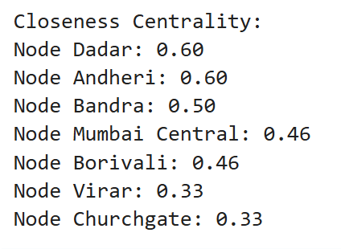

STEP 5: GRAPH CENTERS (ECCENTRICITY)
eccentricity = nx.eccentricity(G)
min_ecc = min(eccentricity.values())
centers = [node for node, ecc in eccentricity.items() if ecc == min_ecc]
print("\nEccentricity of Nodes:")
for node, ecc in eccentricity.items():
print(f"Node {node}: {ecc}")
print(f"\nGraph Centers (Min Eccentricity = {min_ecc}): {centers}")

